# Missouri Mom Arrested AGAIN for Emailing Judge Who Ordered Daughter Into Care of Alleged Abuser

BY [**MEGAN FOX**](https://pjmedia.com/columnist/megan-fox) MAR 08, 2021 7:17 PM ET

Share Tweet

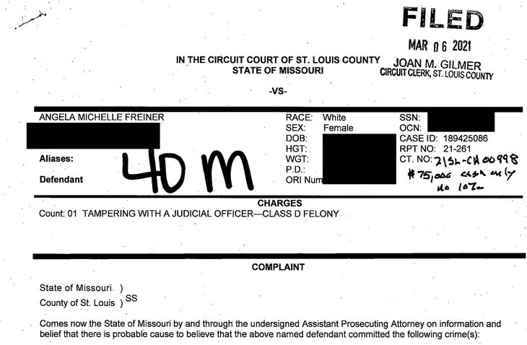

*This report is part 7 of an investigative series looking into reported corruption in the Missouri Judiciary and family courts.* [*For the rest of the investigation visit the catalog here.*](https://pjmedia.com/news-and-politics/megan-fox/2021/05/17/missouri-family-court-corruption-investigation-complete-catalog-n1447471)

Judge Nicole Zellweger and the St. Louis County swamp are not going down without a fight. After being the subject of intense media scrutiny since [audio leaked of Zellweger](https://www.youtube.com/watch?v=HfKpCS_y0Bs&t=244s) ordering a weeping fourteen-year-old to return to the man she says molested her, the retaliation has come down hard and swift on the girl’s mom, Angela Freiner.

Freiner sent an impassioned email to Zellweger after the court jailed her for two days and incarcerated her daughter in the mental ward at St. Louis Children’s Hospital for refusing Zellweger’s order to go quietly with her father.

Freiner wrote:

The court does not have the right to hold my daughter against her will or traffic her across the country! If she is not returned to me today there will be consequences for your conduct. You have stepped over the line for any time of immunity as a judge!

Freiner was arrested on Monday on a class-D felony charge of “tampering with a judicial officer.” What’s unclear to me is how. The email is accurate in every way. The court did indeed hold Freiner’s daughter against her will. You can hear her say that she is being forced across state lines against her will on the recorded hearing, which was leaked to the press. What right does the court have to not only hold a teenager against her will but send her across state lines against her will? What do we call it when adults forcibly move children from one state to another? Consequences for the judge’s conduct are absolutely possible considering that it appears she has violated the judges’ code of conduct. [The code of conduct states](https://www.uscourts.gov/judges-judgeships/code-conduct-united-states-judges) 1) that judges must treat their judicial office as a public trust and 2) that judges must strive to maintain and enhance the public’s confidence in our legal system. On those two items alone Zellweger fails miserably.

What part of jailing a mother trying to report sexual abuse of her daughter “maintains or enhances the public’s confidence in our legal system”? By refusing to swear-in the teen and hear her allegation of abuse at the secretly recorded hearing, how did Zellweger convince the public that she is a person to be trusted? Did Zellweger enhance the public’s confidence when she sent a teen girl to a man who took her to a level-3 sex offender’s house for a week? Does that engender the public’s trust that she is a competent and wise judge?

Zellweger wrote into the record the following information about the father of the child.

Petitioner and the GAL also asked Respondent about the past criminal convictions of Respondant’s father. Respondent testified that he learned during the tendency of this case-from the GAL-that his father is a registered sex offender. His testimony that he was not aware of this until the GAL brought this to his attention during the case is a bit suspect.

Additionally, Respondent testified that he took the Child to Arkansas to visit his parents. At the time, the GAL raised a concern about the Child spending nights at Respondent’s father’s house and Responded told the GAL that he was staying at a hotel. However, Respondent acknowledged during testimony that he only stayed in a hotel one night and spent the rest of the nights at his parents’ house, which was in complete disregard of the GAL’s communications with Respondent. Such flagrant disregard for the GAL’s position 9that the Child not spend an overnight at paternal grandfather’s house) concerns the GAL and this Court.

And now it seems that Zellweger has seen to Freiner being jailed on a $75,000 bond in order to silence her for speaking out about what Zellweger has done to her minor daughter. The unconstitutional gag order Zellweger tried first didn’t work, so maybe jailing Freiner, who is broke, will do the trick. Is that how justice works in St. Louis County?

Another interesting facet of this story is that County Prosecutor Wesley Bell, whose assistant signed the order to go arrest Freiner for her email, hasn’t prosecuted any of the sex abuse of children reported to him by the police in the cases PJ Media is investigating in the Saint Louis County judicial scandal. He also [refuses to prosecute fathers for not paying child support, which was widely reported in the press.](https://www.kmov.com/news/bell-says-putting-those-who-fail-to-pay-child-support-in-jail-will-not-solve/article_38d7df4a-107f-11e9-8e9a-1367abcc10be.html) To restate that, the man who refused to prosecute credible reports of sexual abuse made in police reports that were referred to him DID go after a mom of one of the alleged victims for writing an angry email about it.

That tracks. *St. Louis County is garbage.* God help anyone stuck in its court swamp.

*If you or anyone you know is suffering injustice in the Missouri family court system, please reach out to MeganFox.Writer@protonmail.com. If you are a whistleblower in the court system your identity will be protected.*